TASK 03
K25-0064
Sarim Raza ansari
BAI-2A
Task 01:
EAX: A 32 bit register used to perform arithmetic operations and storing values.
EBX: A 32 bit register use to hold values.
ECX: A 32 bit register used as counter.
EDX: A 32 bit register use to hold data and perform input/output operations.
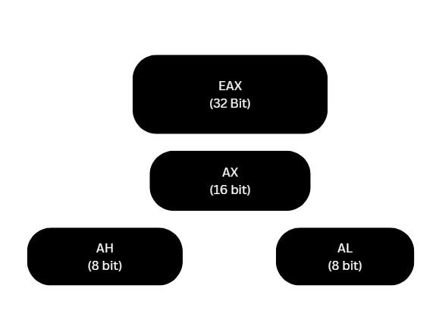
ECX: It is commonly use in counters.
EDX: Use in input/output operations.
Task 02:
.data

rollNo WORD 2201 ; Stores the student's roll number
marks BYTE 87 ; Stores the student's marks out of 100
studentName BYTE "Ali Raza", 0 ; Stores the student's name, null-terminated
grade BYTE ? ; Uninitialized byte for the student's grade

Task 03:
.data

; Attendance of students from Monday to Friday
attendance BYTE 30, 28, 32, 25, 29

; Five empty/uninitialized bytes for future seat information
emptySeats BYTE 5 DUP(?)

Task 04:
.data

buffer BYTE 15 DUP(0) ; Reserves 15 bytes initialized to 0
tempSpace BYTE 10 DUP(?) ; Reserves 10 uninitialized bytes
pattern BYTE 5 DUP("HI") ; Stores "HIHIHIHIHI"

Task 05:
MOV CX, 'B' ; Character constant: ASCII 'B' = 42h = 66 decimal
MOV CX, 42h ; Hexadecimal: 42h = 66 decimal
MOV CX, 66 ; Decimal: 66 = 42h
MOV CX, 01000010b ; Binary: 01000010b = 42h = 66 decimal

Task 06:
TITLE Tuck Shop Cash Register (CashRegister.asm)

INCLUDE Irvine32.inc

.code

main PROC

; Load opening cash balance into EAX
MOV EAX, 5000

; Add sales income
ADD EAX, 1500

; Subtract supply expenses
SUB EAX, 800

; Display final register values
CALL DumpRegs

; Exit program
exit

main ENDP
END main

